[’26 FE] Design of Secure Remote Diag on Container Separation Architecture
Table of Contents
1. About This Document 3
2. Introduction 4
2.1. Purpose 4
2.2. Audience 4
2.3. Abbreviations / Terms 4
2.4. Related Documents 5
3. Project context 6
3.1. Software context 6
3.2. Software Architectural Driver 6
3.3. Background 7
4. 3 Problem Defined 7
4.1. Functional Requirements 7
4.2. Problem Identification 8
4.2.1. Problem Description 8
4.2.2. Problem Analysis 8
4.3. Quality Attributes 9
5. 4 Architecture Alternatives 9
5.1. Alt-A: Split RemoteDiag 9
5.2. Alt-B: Move RemoteDiag 11
5.3. Alt-C: Move RemoteDiag + Proxy 12
5.4. Comparison and decision 15
6. 5 Implementation and Verification 16
6.1. Implementation 16
6.1.1. Forward API call from proxy to remotediag 16
6.1.2. Filter scenario 17
6.2. Verification 17
6.2.1. SidFilter blocks reprogramming diagnostic requests 17
6.2.2. RemoteDiagProxy and RemoteDiag communication 17
6.3. Quality Attributes result 18
7. 6 Conclusion 18
8. Appendix 19
8.1. Diagnostic filtering requirements 19

List of figures
Figure 1 - Current architecture 6
Figure 2 - New architecture (containerized) 6
Figure 3 - RemoteDiag communication paths 7
Figure 4: Alt-A — Split RemoteDiag 9

About This Document
Document Information
Document Title | SW Design
Project | 24DCM LM
Issuing Authority | Toyota
Author | Vu Hoang Phi (phi.vu@lge.com)
Status of Document | Completed
Table 1- Document information

Revision History
Version | Date | Content of Change | Author | Reviewer
01 | 2026.09.28 | Initial Release | phi.vu | by.kim
Table 2- Revision history

Introduction

Purpose
This document presents the software design for Secure Remote Diag on Container Separation Architecture in the Toyota 24DCM LM telematics project. Due to security requirements, the OEM requires the DCM to be separated into two partitions using LXC containers. The document identifies the security risks of the current RemoteDiag communication paths under the new containerized architecture, analyzes the required quality attributes, evaluates multiple architecture alternatives, and provides a comprehensive design solution that blocks unauthorized ECU reprogramming commands and keeps MM ECU diagnostic traffic entirely within the internal container.

Audience
The readers of this article are as follows:
- Software Architect
- Developer
- Project Leader
- Project Manager
- Test Engineer

Abbreviations / Terms
Abbreviation | Description
DCM | Data Communication Module
OEM | Original Equipment Manufacturer
LXC | Linux Containers
EP | Entry Point (container): contains externally exposed network components
IP | Internal Partition (container): contains components with access to the CAN bus
OTA | Over-The-Air (update)
UDS | Unified Diagnostic Services / Unix Domain Socket (per context)
SID | Service Identifier (UDS diagnostic service ID)
RDP | RemoteDiagProxy
OBC | OnBoardClient
MM | MM ECU (OTA Master)
CAN | Controller Area Network
IPC | Inter-Process Communication
ECU | Electronic Control Unit
Table 3- Abbreviations

Related Documents
ID | Title | Version
19PFv3KAI-DCM_Estimation_Cybersecurity_Specification_20251203 | The base Cybersecurity Requirement Specifications and Additional requirements for 19PFv3KAI | --
SEC-ePF-MFG-REQ-SPEC | In-Vehicle Network Requirements Specification of Message Filtering | a03-00-a
Table 4- Related documents

Context

Software context
Toyota DCM is a telematics platform providing connected vehicle services, including remote diagnostics from the OEM server. It supports diagnostic communication and OTA updates through the Internal CAN bus.
The current architecture follows a monolithic deployment model, with all components running in a single partition.
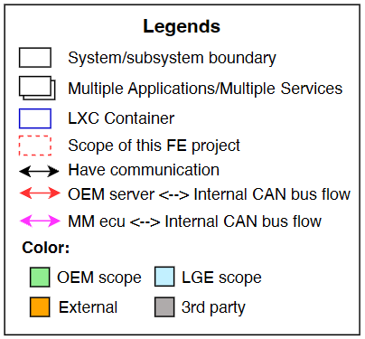
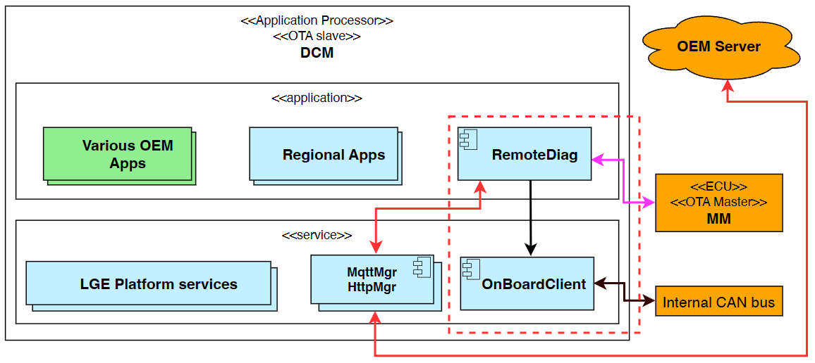
Figure 1 - Current architecture

New Architecture change
Due to security, the OEM wants to separate DCM into 2 partitions using LXC containers:
- EP container (Entry Point): externally exposed network components.
- Internal container (IP): components which have access to the CAN bus.
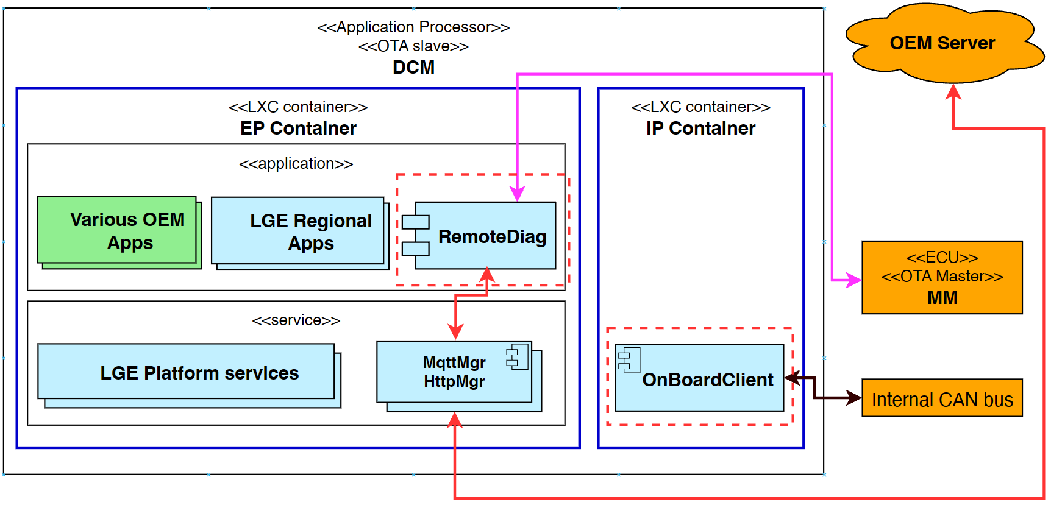
Figure 2 - New architecture (containerized)

3 Problem

Functional requirements
# | Description
FR-01 | The system shall block unauthorized diagnostic commands related to ECU reprogramming.
FR-02 | The system shall route UDS diagnostic messages exchanged with the MM ECU entirely within the IP.

Problem identification

Problem description
RemoteDiag is a module that processes diagnostics for each ECU and uploads diagnostic data to the OEM Server. It has 2 communication paths:
- with OEM Server: performs direct diagnostic commands.
- with MM ECU: OTA diagnostic update.

- Risk: the RemoteDiag ↔ MM path routes through the EP, which is insecure.
The OEM requests that unauthorized reprogramming requests should be filtered.
RemoteDiag’s internal architecture and communication should be redesigned to align with the new architecture.
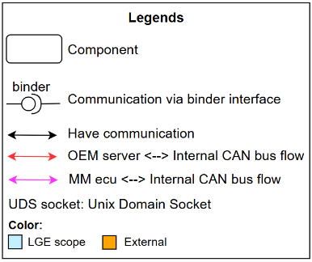
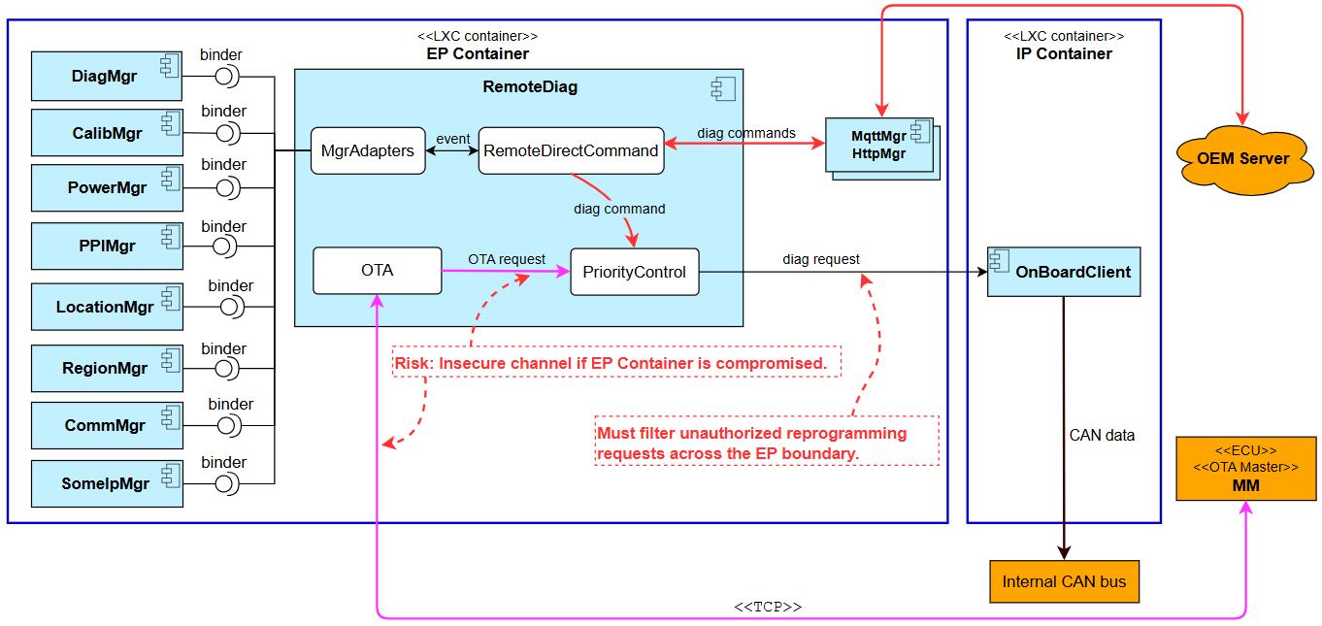
Figure 3 - RemoteDiag communication paths

Problem Analysis
The EP container hosts externally exposed network components (MqttMgr, HttpMgr and OEM applications). If the EP container is compromised, an attacker can inject reprogramming diagnostic requests toward the internal CAN bus through RemoteDiag’s existing communication paths.
The MM ECU OTA diagnostic flow (TCP) currently terminates in the EP container, violating the requirement that diagnostic traffic with the MM ECU must be handled entirely within the IP container.
Therefore the design must (1) filter reprogramming-related SIDs before they reach the internal CAN bus, and (2) relocate the MM ECU diagnostic endpoint into the IP container, while minimizing the impact on the 10+ existing EP-side manager modules that communicate with RemoteDiag over binder IPC.

Quality Attributes
The following quality attributes were carefully considered and prioritized while redesigning RemoteDiag. These attributes guided the architectural decisions and solution selection:
Table 5: Quality Attributes
ID | QA Scenario | Measure | Type | Priority
QA-01 | A compromised app/service sends reprogramming diagnostic to CAN | Zero Reprogramming SIDs reaches the internal CAN. | Security | High
QA-02 | MM ECU sends a diagnostic request via TCP to RemoteDiag | Zero diagnostic communication is found in EP. 100% of requests are handled within IP. | Security | High
QA-03 | The new design preserves the original core responsibility of each component. | No component is required to take responsibilities outside its originally defined role. No additional specification updates caused by responsibility expansion. | Modifiability | High
QA-04 | Existing software components (other than RemoteDiag) require minimal changes. | Number of components which need to be modified to align with the new design. | Maintainability | Medium

Architecture Alternatives

Alt-A: Split RemoteDiag
Split RemoteDiag responsibilities into 2 apps:
- RemoteDiag (EP): handles diag messages from OEM server.
- RemoteOTA (IP): handles OTA diag message flows from MM ECU.
- OnBoardClient is responsible for reprogramming message filtering and diagnostic priority control.
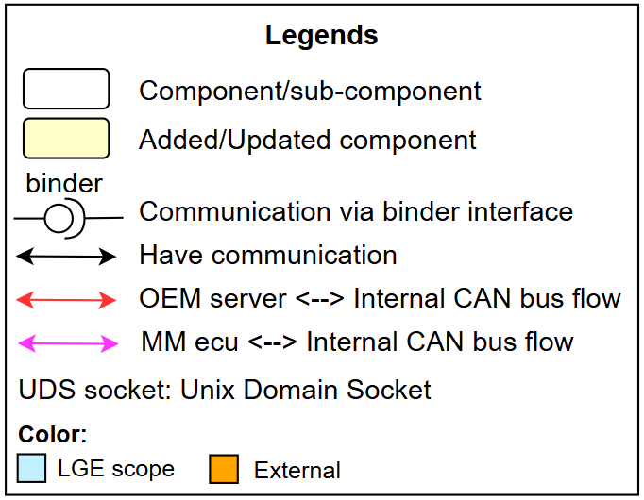
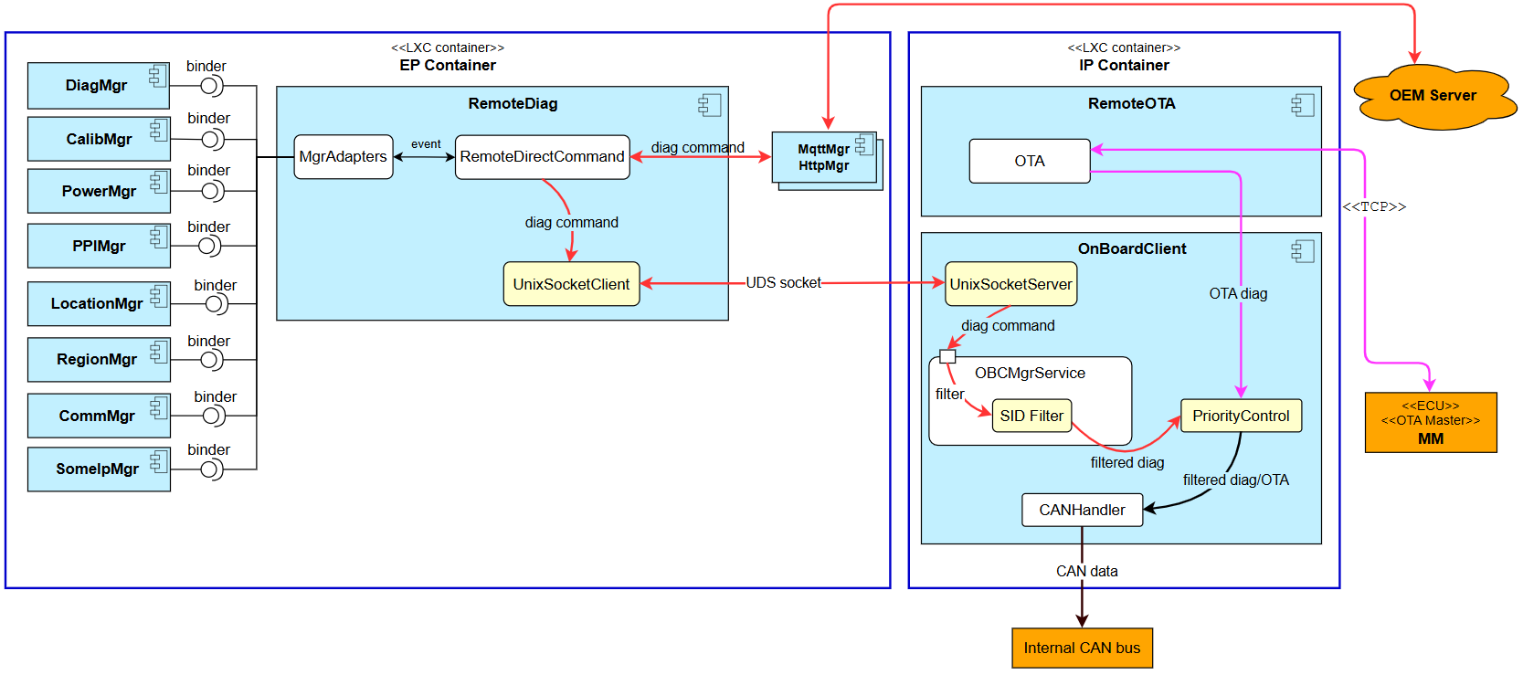
Figure 4: Alt-A — Split RemoteDiag

Alt-B: Move RemoteDiag
- Move RemoteDiag into the IP container.
- To maintain communication with the OEM server and other EP-side components, establish UDS socket connections to each module.
Trade-off — Maintainability: All EP modules require cross-container IPC support, increasing implementation effort and code-change scope.
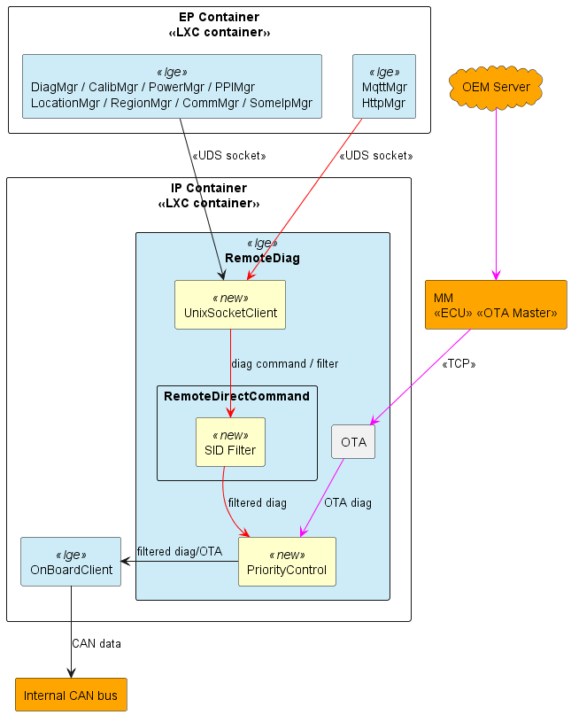
Figure 5: Alt-B — Move RemoteDiag

Alt-C: Move RemoteDiag + Proxy
- Move RemoteDiag into the IP container.
- Add a new RemoteDiagProxy (RDP) component in the EP that acts as a transparent proxy:
  - EP modules continue to interact with RDP using their existing interface.
  - RDP forwards requests to RemoteDiag via a UDS socket channel.
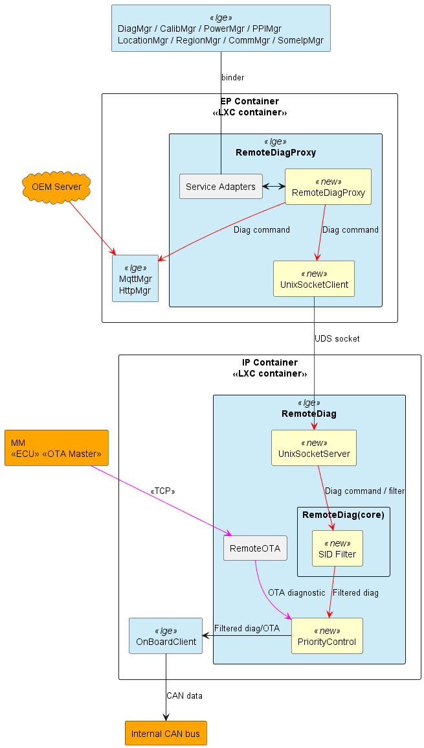
Figure 6: Alt-C — Move RemoteDiag + Proxy

Comparison and decision
Consider the table to see the comparison of the designs:
Table 2: Comparison of architecture alternatives
 | Alt-A – Split RemoteDiag | Alt-B – Move RemoteDiag | Alt-C – Move RemoteDiag + Proxy
QA-01 Security | High — Unauthorized diagnostic commands are filtered. | High — Unauthorized diagnostic commands are filtered. | High — Unauthorized diagnostic commands are filtered.
QA-02 Security | High — MM ECU diagnostic traffic remains within the EP container. (CyberSecurity team confirmed) | High — MM ECU diagnostic traffic remains within the EP container. (CyberSecurity team confirmed) | High — MM ECU diagnostic traffic remains within the EP container. (CyberSecurity team confirmed)
QA-03 Modifiability | Low — RemoteDiag and OnBoardClient’s responsibility is changed (diagnostic priority control is moved to OnBoardClient), requiring requirement updates. | High — Core responsibilities of existing components remain unchanged after migration. | High — Core responsibilities of existing components remain unchanged after migration.
QA-04 Maintainability | Medium — 01 additional component is modified (OnBoardClient — implements UDS socket server and priority control). | Low — 10 EP modules (PowerMgr, HttpMgr, …) have to implement cross-container UDS socket communication and fail-safe handling. | High — No changes required in existing modules. RemoteDiagProxy preserves the current binder interface.
Decision | Rejected | Rejected | Selected
Rating: High = Fully satisfy · Medium = Partially satisfy · Low = Not satisfy
Key Decision Factors:
- Security: All three alternatives satisfy QA-01 and QA-02.
- Modifiability: Alt-B and Alt-C preserve the core responsibilities of the existing components; Alt-A changes the responsibilities of RemoteDiag and OnBoardClient.
- Maintainability: Alt-C requires no changes in existing modules — RemoteDiagProxy preserves the current binder interface, whereas Alt-B forces 10 EP modules to implement cross-container UDS socket communication.
Selected design: Alt-C — Move RemoteDiag + Proxy

5 Implementation and Verification

Implementation

Forward API call from proxy to remotediag
Callback transmission from the EP-side proxy to RemoteDiag in the IP container:
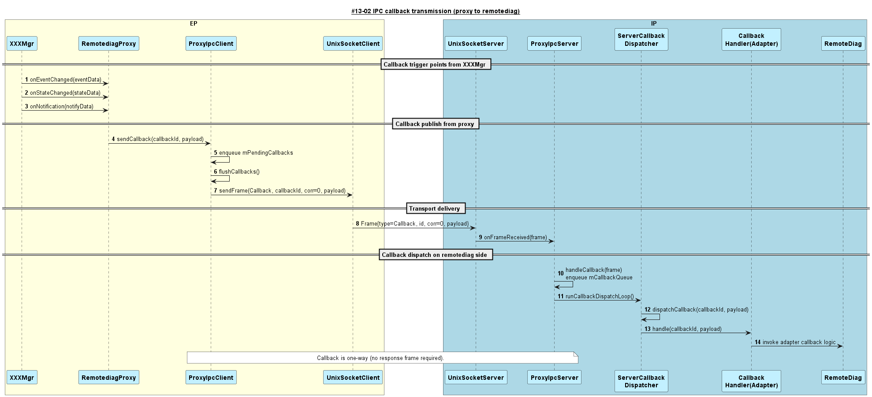
Figure 7: IPC callback transmission (proxy to remotediag)
API request-response from RemoteDiag back to the proxy:
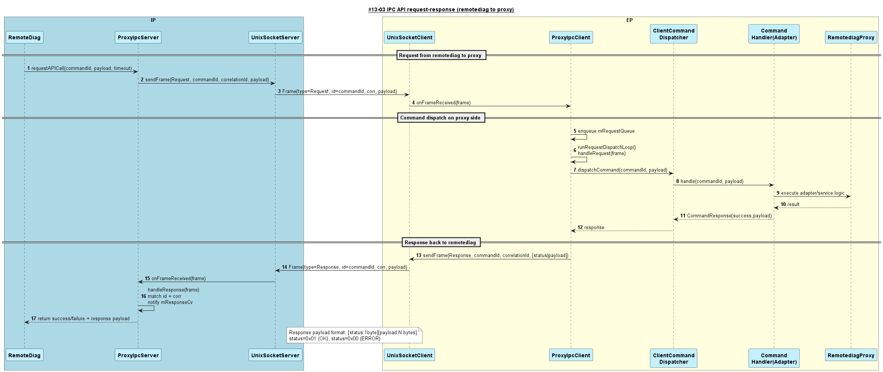
Figure 8: IPC API request-response (remotediag to proxy)
The response payload format is [status: 1 byte][payload: N bytes], where status = 0x01 (OK) and status = 0x00 (ERROR). Callbacks are one-way (no response frame required).

Filter scenario
The diagnostic filter scenario inside the IP container: RemoteDirectCommand validates each direct command and consults SidFilter before pushing the UDS request toward the internal CAN bus.
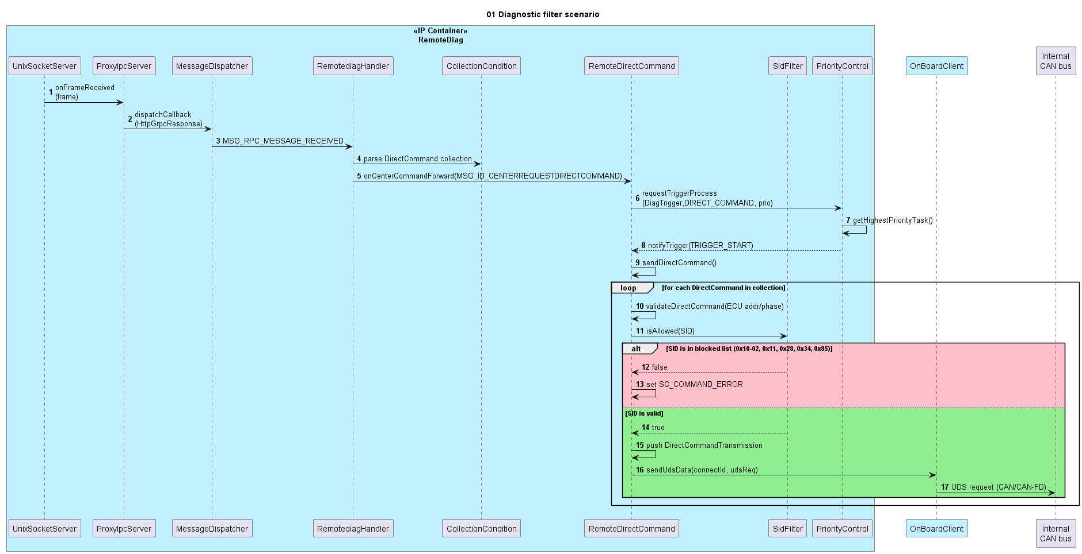
Figure 9: Diagnostic filter scenario

Verification

SidFilter blocks reprogramming diagnostic requests
Runtime log evidence — SidFilter rejects reprogramming-related SIDs before they reach the internal CAN bus:
3555985 66.2025 24LM RDG info [ SidFilter.cpp : isAllowed : 45 ] SidFilter: blocked reprogramming-related request SID 11
3555986 66.2026 24LM RDG info [ RemoteDirectCommand.cpp : validateDirectCommand : 344 ] Ecu list size = 1
3555987 66.2026 24LM RDG info [ SidFilter.cpp : isAllowed : 45 ] SidFilter: blocked reprogramming-related request SID 28
3555989 66.2026 24LM RDG info [ SidFilter.cpp : isAllowed : 45 ] SidFilter: blocked reprogramming-related request SID 85
3555991 66.2027 24LM RDG info [ SidFilter.cpp : isAllowed : 45 ] SidFilter: blocked reprogramming-related request SID 10
3555993 66.2027 24LM RDG info [ SidFilter.cpp : isAllowed : 45 ] SidFilter: blocked reprogramming-related request SID 34

RemoteDiagProxy and RemoteDiag communication
Runtime log evidence — proxy IPC request/response across the UDS socket:
[ VehicleManagerAdapter.cpp : registerServiceLocked : 99 ] Registed Vehicle Manager Service with PID: 1333
[ VehicleManagerAdapter.cpp : registerServiceLocked : 101 ] Registed MsgInd_CanRx_MET1S02
...
[ ProxyIpcServer.cpp : requestAPICall : 219 ] ProxyIpcServer: request start request=VehicleGetTripCounter path=/dev/socket/remotediag/remotediag_proxy.sock timeoutMs=2000 maxRetries=10
[ ProxyIpcServer.cpp : requestAPICall : 247 ] ProxyIpcServer: sending request=VehicleGetTripCounter payloadLen=0 frameSize=8
[ ProxyIpcClient.cpp : dispatchRequest : 381 ] ProxyIpcClient dispatchRequest: command=VehicleGetTripCounter(9002) payloadLen=0
[ ProxyIpcServer.cpp : requestAPICall : 300 ] ProxyIpcServer: request complete request=VehicleGetTripCounter status=OK payloadLen=5

Quality Attributes result
Table 3: Quality Attributes result
Quality Attribute | Priority | Description | Result
QA-01 Security | High | Zero reprogramming SIDs reach the internal CAN — SidFilter blocks SID 0x10-02, 0x11, 0x28, 0x34, 0x85. | ✅
QA-02 Security | High | MM ECU diagnostic requests are handled entirely within the IP container. | ✅
QA-03 Modifiability | High | Core responsibilities of existing components remain unchanged after migration. | ✅
QA-04 Maintainability | Medium | No changes required in existing modules; RemoteDiagProxy preserves the current binder interface. | ✅

6 Conclusion
The evaluation of three architecture alternatives (Split RemoteDiag, Move RemoteDiag, and Move RemoteDiag + Proxy) determined that Alt-C — moving RemoteDiag into the IP container together with a transparent RemoteDiagProxy in the EP container — provides the best balance of security, modifiability, and maintainability. Verification results confirm that both functional requirements are satisfied: SidFilter blocks all reprogramming-related SIDs (FR-01), and MM ECU diagnostic communication is handled entirely within the IP container (FR-02), while existing EP modules continue to use their unchanged binder interfaces through the proxy.

Appendix

Diagnostic filtering requirements
5.1. Diagnostic Filtering Targets —【MFGREQ_00005】
The ECU shall target the diagnostic request message excluding the legally applicable diagnostic communication addresses for diagnostic filtering. (For diagnostic communication addresses, refer to “Related Documents [2][10]”.)
(Supplement) “Reserve” in service tools and remote diagnostic response messages may be set in diagnostic request messages. Therefore, refer to the latest diagnostic address, and be careful not to exclude the diagnostic request message from the filtering target.
5.2. Diagnostic Filtering Implementation Details —【MFGREQ_00006】
The ECU shall discard diagnostic request messages in Table 5-1 by diagnostic filtering.
Table 5-1: Diagnostic requests to be filtered (Phase 5, 6)
SID | Description
0x10 | DiagnosticSessionControl — Programming session (0x02)
0x11 | ECUReset
0x28 | CommunicationControl
0x34 | RequestDownload
0x85 | ControlDTCSetting
5.3. Diagnostic Filtering Deactivate Conditions —【MFGREQ_00007】
The ECU shall deactivate the diagnostic filtering of MFGREQ_00006 if the center connection device authentication completed successfully. For center connection device authentication, refer to “Related Documents [3]”.
5.4. Reactivating after Diagnostic Filtering deactivation —【MFGREQ_00016】
After the deactivation of the diagnostic filtering in【MFGREQ_00007】, the ECU shall reactivate the diagnostic filtering before the authentication state of the center connection device authentication transitions to “Unauthenticated” state. For the authentication state of the center connection device authentication, refer to “Related Documents [3]”.
TOYOTA MOTOR CORPORATION

